Forecasting WCS Prices

An in-depth paper on forecasting the prices of Canada’s main benchmark for its heavy crude oil

Timothy Lau 1444107

ECON 493 F18A1

S.F. Pereira

December 7, 2018

Abstract:

This is a time series forecasting analysis on the price of WCS, a benchmark for Canadian heavy crude oil. A dynamic regression model was fit to the data and an ARIMA model was fit to the residuals; however, given the nature of the data, a VAR(2) model was chosen instead. It is expected that the prices will rise for the rest of 2018, and stabilize during the third of 2019; the expected value of WCS prices in August 2018 is US$52.62/barrel.

**Introduction**

The intent of this paper is to forecast the price of Western Canada Select (WCS), a pricing benchmark for Canadian heavy crude oil. The data was collected from a multitude of sources; Statistics Canada, National Energy Board, Energy Information Administration, and the Federal Reserve Bank of St. Louis. The data is monthly and ranges from January 2009 to July 2018.

Crude oil, a naturally occurring fossil fuel, is an essential part of the global energy market and is consumed daily worldwide; it is typically refined into more practical commodities – most commonly in the form of petroleum, gasoline, and diesel. As one of its main products and exports, crude is an integral source of income for Alberta’s economy. In order to measure its price and keep its competitiveness with US oil, WCS was created as a benchmark for heavy Canadian crude.

This paper will utilize dynamic regression model (DRM) techniques to forecast WCS prices. Modelling the price of WCS requires consideration of several key factors. Even though WCS has been a benchmark for Canadian crude since 2004, many still price WCS as a differential to WTI – the benchmark for US crude – as well as Mexican MAYA – the global benchmark for crude. This is often attributed to the fact that, because of Alberta’s landlocked nature, 99% of Canadian crude exports go to the US. As such, the pricing of WCS depends heavily on these international price criterions. Another component important to modelling WCS is the strength of the economy relative to its trade partners. Because Canada practically exports exclusively to the US, the exchange rate between the two can be used as a proxy variable for economy strength. Economically, it is important to consider demand for a good when modelling its price. To model the demand for Canadian crude, proxy variables will once again be used. A large bulk of the crude the US imports from Canada are sent to PADDs II and III for refinery; as such, the utilization of refinery operational of these two PADDs’ capacity – which models capacity constraints – as well as the amount of crude the US imports, will be taken into account for the model[1].

|  |  |  |  |  |  |  |  |
| --- | --- | --- | --- | --- | --- | --- | --- |
|  | WCS | WTI | MAYA | EXCH | PADD2 | PADD3 | Usimports |
| Min | 16.3 | 30.32 | 24.21 | 0.9553 | 77.4 | 78.1 | 52971 |
| 1st Qu. | 38.3 | 50.82 | 46.1 | 1.0221 | 88.38 | 87.33 | 69096 |
| Median | 60.05 | 75.68 | 67.59 | 1.0966 | 91.75 | 90.8 | 81200 |
| Mean | 56.79 | 73.31 | 69.92 | 1.1435 | 91.09 | 89.94 | 82897 |
| 3rd Qu. | 72.83 | 94.6 | 94.47 | 1.2784 | 93.97 | 93.33 | 99402 |
| Max. | 90.97 | 110.04 | 111.9 | 1.4208 | 99.1 | 97.5 | 119871 |

Table 1. Summary statistics of the data being used.

**Methodology**

Because we are using DRMs, several problems arise due to the nature of this model; in classical regression models, the idea is to minimize the sum of squared errors. However, because we are now using a portion of the errors to explain the data, we minimize the sum of squared ARIMA errors instead, leading to several problems with the regression model:

* Estimated coefficients of the regression part of the model are no long BLUE
* Statistical tests associated with the model are incorrect; p values for coefficients are also affected – in this case, these are typically biased towards zero, which leads to spurious regressions
* Information criterion are no longer an adequate guide in choosing models for forecasting

A remedy for this problem is to split the forecasts into two parts – the regression part and the ARIMA part – and recombined at the end.

To begin analysis of WCS prices, an ARIMA model must be fit to the residuals of the model: we first fit the model with the regressors mentioned above, and analyze the subsequent residuals.

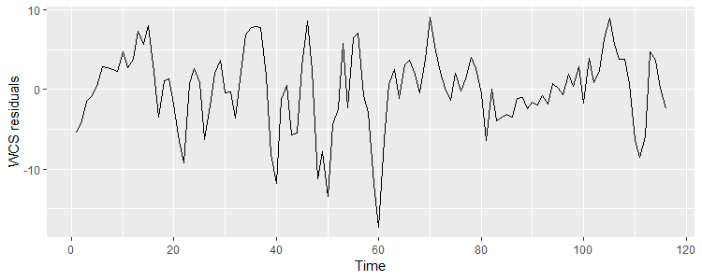

Figure 1. WCS residuals from regression of WCS price on WTI price, MAYA price, exchange rate, PADD 2 and 3 utilization rate, and amount of Canadian crude imported by US.

As shown in Figure 1, the residuals of the regression form some sort of white noise; there is no visible trend factor in the residuals, as the mean seems to hover around zero, save for the large outlier in period 60. In order the check for a seasonal factor, the autocorrelation function (ACF) plot is observed:

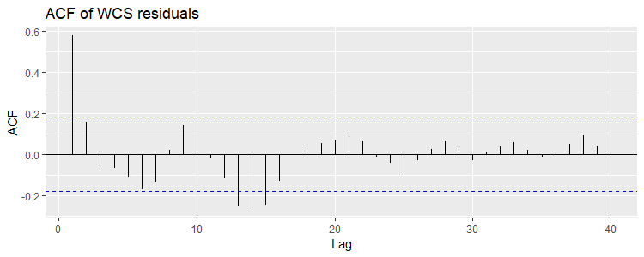

Figure 2. The ACF of residuals obtained from regression above.

In Figure 2, there is no discernable pattern of significant autocorrelations over a set period of time – for example, there does not seem to be a significant AC at periods 12, 24, and 36 – suggesting that there is no seasonal pattern present in WCS residuals. This implies that either the seasonal pattern is already explained by regressors in the dynamic model, or that there is none at all.

*Data Transformation*

The variance in the residuals is non-constant – the data is non-stationary, which is needed in order to fit an ARIMA model. To resolve this, transformation of the data is necessary.

The first attempt was to take the log of the residuals. This resulted in missing values of the data. Attempting to bypass this, we take the log of the residuals plus some constant. This transformation did not have a significant impact on minimizing the variance difference from the residuals.

In the second attempt, a BoxCox (lambda = 1/3) transformation is performed on the data. As portrayed in Figure 3, there has been major reductions in the non-conformity of the variance. As such, the BoxCox of WCS residuals will be used in modelling the price of WCS.

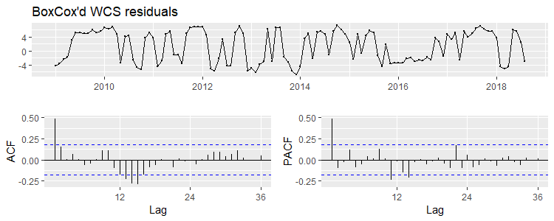

Figure 3. The BoxCox’d WCS residuals, ACF, and PACF, given by the ‘ggtsdisplay’ command.

When observing the ACF and PACF plots, there seems to be no need for any differencing. When performing the Augmented Dickey Fuller test, where the null hypothesis is that the data is non-stationary, the resulting t-statistic is -5.5637, whereas the 10% critical value is -1.62. Therefore, we have enough evidence to reject the null hypothesis that there is non-stationarity in the data.

|  |  |  |  |  |  |
| --- | --- | --- | --- | --- | --- |
| Null Hypothesis | Test Statistic | Critical values | | | P value |
| 1 | 5 | 10 |
| Non-Stationarity (unit root present | -5.5637 | -2.58 | -1.95 | -1.62 | 1.82*10^-7 |

Table 1. ADF test on BoxCox’d WCS residuals.

*Model Selection*

The ACF and PACF both have a significant spike at lag 1 and drop exponentially to zero. The following significant lags can be explained by white noise; the ACF presents a sinusoidal pattern. These suggest an autoregressive as well as a moving average component. Because the only significant lags are at 1, an ARIMA(1,0,1) is suggested.

When using the auto-ARIMA function, the software suggests an ARIMA(1,0,0) with a non-zero mean. In order to choose between the two models, we compare AICc.

_____________________________________________________________

Series: WCSBCTS

ARIMA(1,0,0) with non-zero mean

Coefficients:

ar1 mean

0.4898 1.2501

s.e. 0.0813 0.7050

__________________________________________________________

Figure 4. auto-ARIMA suggested model: ARIMA(1,0,0).

__________________________________________________________

Series: WCSBCTS

ARIMA(1,0,1) with non-zero mean

Coefficients:

ar1 ma1 mean

0.3667 0.1657 1.2645

s.e. 0.1522 0.1530 0.6603

__________________________________________________________

Figure 5. ARIMA(1,0,1) of the WCS residuals.

|  |  |  |  |  |  |  |
| --- | --- | --- | --- | --- | --- | --- |
| p | d | q | AIC | AICc | BIC | RMSE |
| 1 | 0 | 0 | 651.42 | 651.63 | 659.68 | 3.903 |
| 1 | 0 | 1 | 652.37 | 652.73 | 663.38 | 3.886 |

Table 2. The respective information criterion of the two suggested ARIMA models

The software-suggested model outputs the lowest information criterion across the board, suggesting that it performs better than its competitor. However, the RMSE of the latter model is smaller; this suggests that the two models perform very similarly in quality.

When observing the forecasts produced by either model, they are visibly identical; the prediction intervals differ very minimally. To resolve this, we continue on with the forecast construction and see which one performs better.

*Forecasting*

As discussed before, because we are using DRMs, we have to segregate the model into two parts in order to forecast: residuals and regressors.

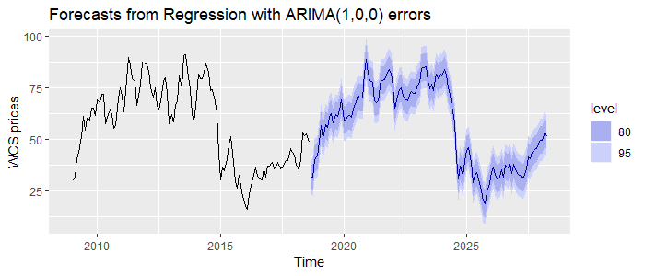

Figure 6. Generated forecasts of WCS prices using DRM with ARIMA(1,0,0) errors.

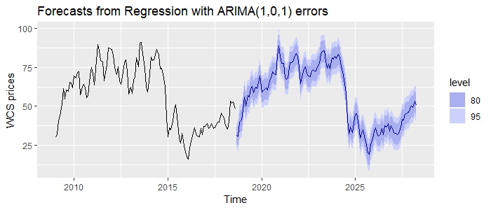

Figure 7. Generated forecasts of WCS prices using DRM with ARIMA(1,0,1) errors.

Note that, visibly, the two models perform very similarly. However, when checking residuals, it seems that the model fitted with ARIMA(1,0,1) errors perform better when explaining the autocorrelations.

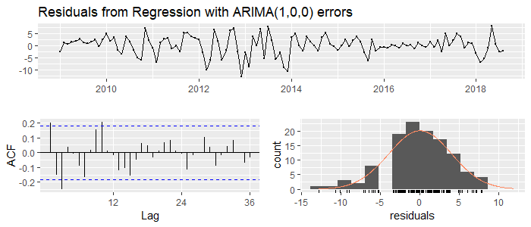

Ljung-Box test

data: Residuals from Regression with ARIMA(1,0,0) errors

Q* = 37.998, df = 15.2, p-value = 0.001004

Model df: 8. Total lags used: 23.2

Figure 8. Residuals, ACF, and residual statistics of DRM fitted with ARIMA(1,0,0) errors.

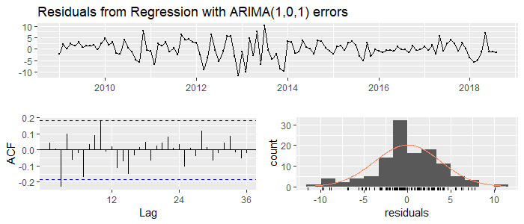

Ljung-Box test

data: Residuals from Regression with ARIMA(1,0,1) errors

Q* = 25.328, df = 14.2, p-value = 0.034

Model df: 9. Total lags used: 23.2

Figure 9. Residuals, ACF, and residuals statistics of DRM fitted with ARIMA(1,0,1) errors.

While neither model can fully capture the autocorrelations present in the residuals, the ARIMA(1,0,1) model only has one significant lag at lag 3, whereas the ARIMA(1,0,0) model has several. Therefore, we conclude by using the DRM fitted with ARIMA(1,0,1) errors for forecasting.

**Forecast Discussion: Problems**

When we construct the forecast, the software does two specific things: firstly, it fixes the number of periods being forecasted to the amount of periods that was present in the data regardless of the command given; secondly, the forecasts generated are practically a copy of the historical WCS prices.

What this is is that the software simply takes the last period given and tries to forecast that, but because we have forced the model to be shaped by the explanatory variables, the forecasts are also forced to take the shape of the model. This implies that the software cannot forecast the data, which may be due to a variety of reasons. The most likely is that this is price data, and like stock price data, forecasting it is near impossible. A way to prove this is to try to fit a DRM with ARIMA errors to the differenced data.

________________________________________________________________________

Series: WCSD

Regression with ARIMA(0,0,0) errors

Coefficients:

WTI MAYA EXCH PADD2 PADD3 Usimports

0.8934 0.1104 31.4817 -0.0428 0.1505 -1e-04

s.e. 0.1974 0.2074 21.6186 0.1093 0.1093 1e-04

________________________________________________________________________

Figure 7. auto-ARIMA fitted model for regression of differenced WCS on differenced regressors.

An ARIMA(0,0,0) model is fitted to the residuals, suggesting that outside of the regression, the residuals are white noise – meaning that there is no useful information left over, and that all the autocorrelations have been explained by the regression – as typical of price data.

If the dynamic regression model has explained all of the autocorrelations, perhaps just forecasting WCS prices with a standard ARIMA model could show something useful. Because WCS prices were non-stationary, a difference was applied before using auto-ARIMA to fit a model.

___________________________________________________

Series: diff(datats[, 2])

ARIMA(0,0,0) with zero mean

sigma^2 estimated as 44.92: log likelihood=-381.96

AIC=765.93 AICc=765.96 BIC=768.67

___________________________________________________

Figure 8. auto-ARIMA fitted model for differenced WCS prices.

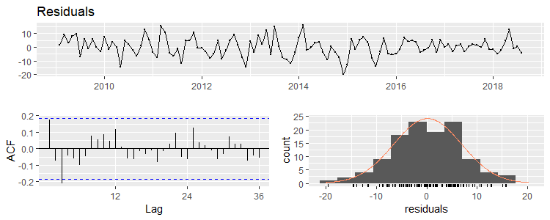

Figure 9. Differenced WCS prices.

As observed in figure 9, there is simply no autocorrelation data that the software could fit an ARIMA model to. Even when trying to model the non-differenced prices, auto-ARIMA just fits a difference and predicts an ARMA(0,0). As a result, any forecasts generated by DRMs with ARIMA errors for this data are useless.

**Forecast Discussion: Alternatives**

*Naïve Model*

A potential model for useful forecasts that can be derived are the next-period forecasts, using forecasts equal to the previous observed value. These forecasts are known as naïve forecasts.

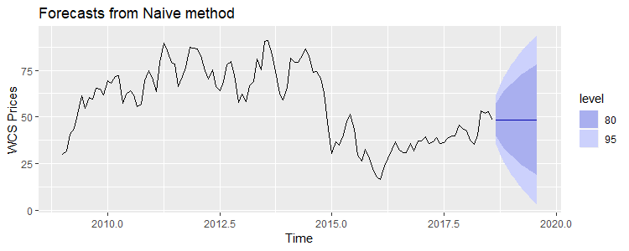

Figure 10. Naïve forecasts of WCS prices.

Because this is pricing data, the only useful prediction is the one period ahead forecast:

|  |  |  |  |  |  |
| --- | --- | --- | --- | --- | --- |
|  | Point Forecast | Lo 80 | Hi 80 | Lo 95 | Hi 95 |
| Sep-18 | 48.55 | 39.96042 | 57.13958 | 35.41337 | 61.68663 |

Table 3. WCS price forecast for one period ahead using naïve method.

However, because the data seems not to hover for some time at any given point, and given the fluctuating nature of such types of prices, expecting WCS prices to stay at a certain level over any period of time does not seem to be very reasonable. While naïve forecasts may be useful in some circumstances, they do not seem to be effective for accurate and precise WCS prices for long periods of time; only being able to predict one period ahead seems very limiting.

*VAR(n) Model*

A third model that is potentially useful in forecasting pricing data and is explicitly more powerful than either of the two previous iterated models is vector autoregressions (VAR). Here, each variable is modelled such that each influence each other equally. Because each variable is forecasted as an autoregression of itself, VAR does not run into the same problems as DRMs, where DRMs have potential issues with forecasting due to its multivariate nature. VARs use the forecasts of the regressors to model forecasts for the variable of interest.

A major problem going into using a VAR model is over estimation. Even if every variable introduced is important to the model, including too many variables results in an over estimation of coefficients, increasing the estimation error for forecasting dramatically. As such, we will have to remove several variables going into this model – here, we will remove the following variables: MAYA, PADDIII; US imports[2]. When choosing the amount of lags to include, information criteria will be utilized.

It is important to note that the variable “PADDII” is an exogenous variable; it is not a market variable like the rest, and therefore its forecasts should not be affected by forecasts of market variables.

________________________________________________________

$`selection`

AIC(n) HQ(n) SC(n) FPE(n)

2 2 2 2

________________________________________________________

Table 4. VAR lag selection.

All the information criterion suggest a VAR(2) model. Performing the Portmanteau test for the model:

_________________________________________________________

Portmanteau Test (asymptotic)

data: Residuals of VAR object var3

Chi-squared = 74.256, df = 72, p-value = 0.4046

_________________________________________________________

Table 5. Portmanteau test for VAR(2)

The model passes the test for serial correlation; therefore, we continue to use this model for forecasting.

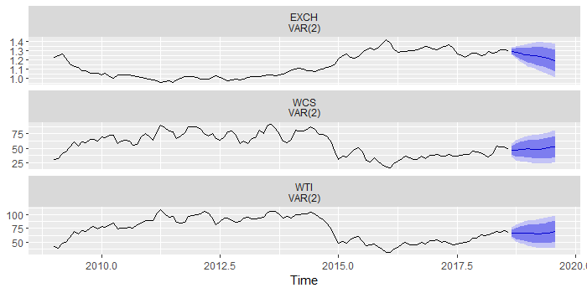

Figure 11. VAR(2) forecasting with WCS, WTI, EXCH, and PADDII as an exogenous variable.

|  |  |  |  |  |  |
| --- | --- | --- | --- | --- | --- |
| WCS (US$/b) | Point Forecast | Lo 80 | Hi 80 | Lo 95 | Hi 95 |
| Sep-18 | 46.51273 | 38.77508 | 54.25037 | 34.67902 | 58.34643 |
| Oct-18 | 46.18949 | 34.98081 | 57.39817 | 29.04729 | 63.33169 |
| Nov-18 | 47.37266 | 34.42204 | 60.32328 | 27.56639 | 67.17892 |
| Dec-18 | 48.41177 | 34.39689 | 62.42664 | 26.97787 | 69.84566 |
| Jan-19 | 48.73149 | 33.93635 | 63.52662 | 26.10428 | 71.3587 |
| Feb-19 | 48.4454 | 33.00216 | 63.88863 | 24.82701 | 72.06378 |
| Mar-19 | 48.14085 | 32.09915 | 64.18255 | 23.60718 | 72.67451 |
| Apr-19 | 48.37325 | 31.76678 | 64.97972 | 22.97585 | 73.77065 |
| May-19 | 48.92875 | 31.80429 | 66.05322 | 22.73914 | 75.11837 |
| Jun-19 | 50.2742 | 32.68456 | 67.86384 | 23.37316 | 77.17523 |
| Jul-19 | 51.67799 | 33.67067 | 69.6853 | 24.13818 | 79.21779 |
| Aug-19 | 52.61832 | 34.23179 | 71.00485 | 24.49855 | 80.73809 |

Table 6. VAR(2) forecasts of WCS prices.

As observed in Figure 12 and Table 5, the price of WCS is expected to rise steadily for the rest of 2018 as well as the first two quarters of 2019 and then stabilizing during the third quarter of 2019. While these may be the best forecasts obtainable from the models presented, it should be noted that prices are not likely to follow such a uniform pattern, as evidenced by the growing prediction intervals over time. It is important to note that the forecasts seem to be following the most recent trend in the data and then just regressing to the mean of the data.

**Results**

Based on the outcome of the model construction, a DRM with ARIMA(1,0,1) errors was chosen as the best model to fit the data. However, due to the nature of the data, it was concluded that the DRM method did not produce useful results, and consequently, the naïve method was chosen as to forecast the WCS prices. Using this model to forecast the price of WCS for September 2018, the expected price of WCS is US$48.55 per barrel. However, expecting WCS prices, which behave like stock prices, to hover for an amount of time, is inaccurate, nor are one-period ahead forecasts very interesting.

Fitting a VAR(n) model to the data, a VAR(2) was chosen. The forecasts obtained from this model suggests that the prices rise for several months but do stabilize in the following year. The expected price of WCS is US$52.62 per barrel.

**Conclusion**

An analysis of the price of WCS has shown that, like stock prices, they are unpredictable without the help of a very powerful model. There was a dramatic increase in price for several years, post-2008 market crash, and while the prices dropped significantly in late-2014 to early 2016, they are slowly regressing to the mean. The price of WCS is affected by many market variables: the performance of international benchmarks, the strength of the economy, and demand. As such, a dynamic regression model with ARIMA errors was proposed to model the crude oil benchmark prices.

However, due to the nature of the data, the initially proposed model yielded useless forecasts, and was subsequently discarded in favour for a more powerful model that used the forecasts of the regressors to forecast the dependent variable.

In conclusion, the recommended model is a VAR(2) model, which suggests that the price will rise relatively slowly, following the most recent trend in the past couple months. The expected price of WCS in August 2019 is US$52.62 per barrel.

**Appendix**

1. **Important Note**

It should also be noted that these prices are a prediction of what is to come *given the parameters of the model*. The model does not take many different current events or market shocks that are currently transpiring into account. A considerable example would be the Trans-Mountain Pipeline Expansion. While this project is currently in limbo, it potentially opens Canada up to a very hungry Asian market as well as a new, much higher priced benchmark based in Shanghai, driving Canadian crude prices up. Another factor that may force reality away from these forecasts is the on-going trade war between the US and China; with major tariffs going up in both countries, Chinese buyers have reduced much of their demand for US oil and have looked elsewhere. Coupled with the pipeline, this should cause WCS prices to rise dramatically – though, granted, construction of the pipeline should take several years whereas we have only forecasted 12 months of prices.

More recently, in October, multiple week long maintenance shutdowns by multiple refineries happened simultaneously in the US, causing major capacity constraints. The lowered demand for Canadian crude depressed WCS prices substantially. Because of data constraints, the model was built upon data that went up to August; as such, even while the model suggests that the prices of WCS will drop in October, as they have, the forecasts will not be very accurate due to this major shock. As of November 14, 2018, the prices of WCS have dropped to US$14.65/b; none of the forecasts projected in this paper come even close to predicting this.

To somewhat model this relationship, we take our current VAR(2) model and allow the exogenous variable “PADDII” to be endogenous. While this is unrealistic, we do observe that the resulting drop in refinery operability rate causes WCS prices to drop dramatically.

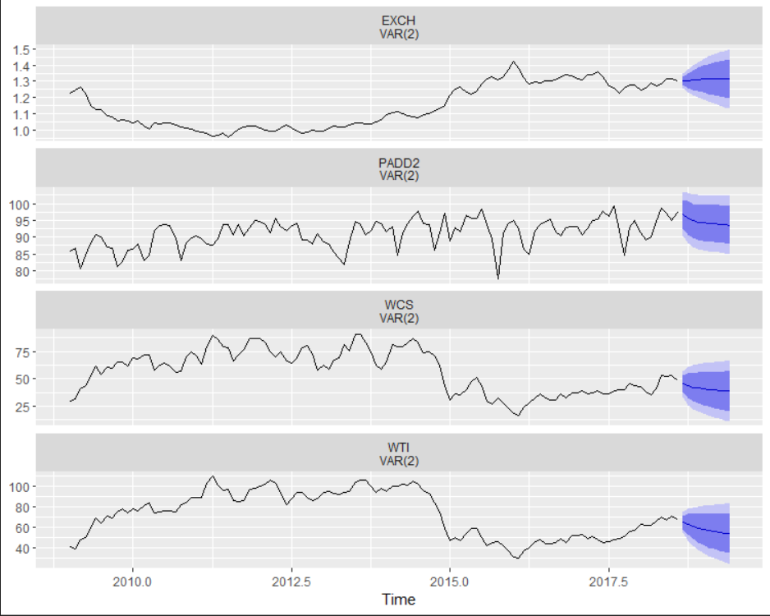

Figure 12. VAR(2) forecasting with WCS, WTI, EXCH, and PADDII.

A 3% drop in refinery operability rate results in a point forecast of US$38.52/b, a 26.7% drop in prices. It’s important to note that the drop in PADDII will also cause a drop in WTI prices which cascades to WCS prices.

1. **VAR(n) with all variables (see page 8)**

> VARselect(datats[,2:8], lag.max=8,

+ type="const")[["selection"]]

________________________________________________________

$`selection`

AIC(n) HQ(n) SC(n) FPE(n)

2 1 1 2

________________________________________________________

Table 8. VAR lag selection.

The software suggests one or two lags to include in the model. Perform PT tests for serial correlation:

var1 <- VAR(datats2[,2:5], p=1, type="const")

serial.test(var1, lags.pt=10, type="PT.asymptotic")

_________________________________________________________

Portmanteau Test (asymptotic)

data: Residuals of VAR object var1

Chi-squared = 531.47, df = 441, p-value = 0.001977

_________________________________________________________

Table 9. Portmanteau test for VAR(1)

var2 <- VAR(datats2[,2:5], p=2, type="const")

serial.test(var2, lags.pt=10, type="PT.asymptotic")

_________________________________________________________

Portmanteau Test (asymptotic)

data: Residuals of VAR object var2

Chi-squared = 426.11, df = 392, p-value = 0.1135

_________________________________________________________

Table 10. Portmanteau test for VAR(2)

From the PT tests, we see that VAR(1) doesn’t pass the serial correlation test whereas VAR(2) does. Therefore, we select VAR(2) as the model to continue forecasting.

varfc = forecast(var2)

autoplot(varfc)

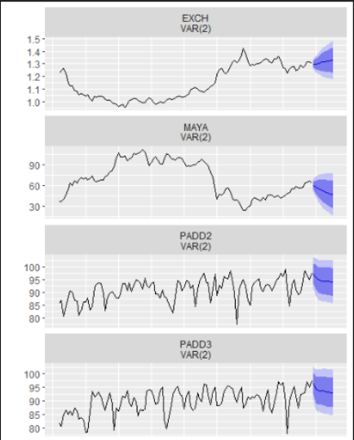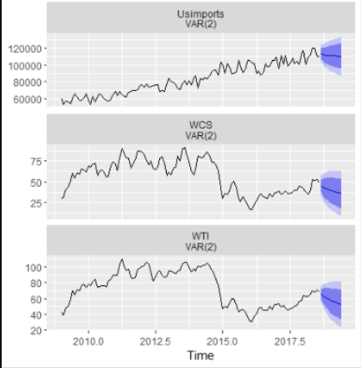

Figure 13. VAR(2) forecasts with all variables from DRM model.

varfc

|  |  |  |  |  |  |
| --- | --- | --- | --- | --- | --- |
| WCS | Point Forecast | Lo 80 | Hi 80 | Lo 95 | Hi 95 |
| Sep-18 | 45.50352 | 37.79946 | 53.20759 | 33.721169 | 57.28588 |
| Oct-18 | 43.46092 | 32.6221 | 54.29974 | 26.884377 | 60.03747 |
| Nov-18 | 41.9622 | 29.27961 | 54.6448 | 22.565852 | 61.35856 |
| Dec-18 | 40.95967 | 26.93336 | 54.98599 | 19.508278 | 62.41107 |
| Jan-19 | 40.08247 | 25.10124 | 55.0637 | 17.17065 | 62.99429 |
| Feb-19 | 39.20378 | 23.55483 | 54.85273 | 15.270775 | 63.13678 |
| Mar-19 | 38.32406 | 22.13605 | 54.51208 | 13.56663 | 63.08149 |
| Apr-19 | 37.52488 | 20.83975 | 54.21001 | 12.00717 | 63.04259 |
| May-19 | 36.84697 | 19.68672 | 54.00722 | 10.602635 | 63.09131 |
| Jun-19 | 36.28708 | 18.67556 | 53.89859 | 9.352589 | 63.22156 |
| Jul-19 | 35.81449 | 17.77622 | 53.85276 | 8.227335 | 63.40164 |
| Aug-19 | 35.40017 | 16.95718 | 53.84316 | 7.194052 | 63.60629 |

Table 11. VAR(2) forecasts with all variables from DRM model.

Let this model be denoted as the full VAR model and the model in Appendix(i) be denoted the limited model. As observed in Figure 13 and Table 11, compared with Figure 12, we see that the full model forecasts WCS prices to drop significantly more than the limited model. The full model even suggests that the price will continue on a negative trend rather than stabilizing in the follow year as predicted by the latter model. By August 2019, the former predicts that WCS will be priced at US$35.40/b, compared to US$38.32/b – approximately a 7.6% decrease in the predictions. It should also be noted that the prediction intervals in the full model for WCS are tighter. More knowledge is required to test the change in estimation error this model exudes in order to evaluate whether or not this model is worth looking into as a valid rival to the recommended model.

1. **Variable Definition**

|  |  |  |
| --- | --- | --- |
| **Variables** | **Definitions** | **Source** |
| **WCS (US$/b)** | Western Canadian Select; the variable being forecasted, WCS is the Canadian pricing benchmark for heavy crude oil. | “Economic Dashboard.” *Oil Prices*, 26 Oct. 2018, economicdashboard.alberta.ca/OilPrice. |
| **WTI (US$/b)** | Western Texas Intermediate; WTI is the US pricing benchmark for crude oil. | “Economic Dashboard.” *Oil Prices*, 26 Oct. 2018, economicdashboard.alberta.ca/OilPrice. |
| **MAYA (US$/b)** | Mexican MAYA; one of the many global benchmarks for crude oil, it is mainly used in the Gulf Coast in the US. | “US FOB Costs of Mexican MAYA Crude Oil.” *Factors Affecting Gasoline Prices - Energy Explained, Your Guide To Understanding Energy - Energy Information Administration*, 1 Nov. 2018, www.eia.gov/dnav/pet/hist/LeafHandler.ashx?n=PET&s=IMX2810004&f=M. |
| **EXCH (CAD:US)** | Exchange rate between Canadian and American currencies. | “Canada / U.S. Foreign Exchange Rate.” *FRED*, Federal Reserve Bank of St. Louis, 13 Nov. 2018, fred.stlouisfed.org/series/EXCAUS. |
| **PADD II** | The utilization rate of refinery operable capacity in PADD II, measures capacity constraints; districts of energy in the US are separated into PADDs. | “Midwest (PADD II) Percent Utilization of Refinery Operable Capacity.” *Factors Affecting Gasoline Prices - Energy Explained, Your Guide To Understanding Energy - Energy Information Administration*, 31 Oct. 2018, www.eia.gov/dnav/pet/hist/LeafHandler.ashx?n=PET&s=MOPUEP22&f=M. |
| **PADD III** | The utilization rate of refinery operable capacity in PADD III, measures capacity constraints; districts of energy in the US are separated into PADDs. | “Midwest (PADD III) Percent Utilization of Refinery Operable Capacity.” *Factors Affecting Gasoline Prices - Energy Explained, Your Guide To Understanding Energy - Energy Information Administration*, 31 Oct. 2018, www.eia.gov/dnav/pet/hist/LeafHandler.ashx?n=PET&s=MOPUEP32&f=M. |
| **Usimports** | Amount of monthly crude oil the US imports from Canada. | “US Imports from Canada of Crude Oil.” *Factors Affecting Gasoline Prices - Energy Explained, Your Guide To Understanding Energy - Energy Information Administration*, 31 Oct. 2018, www.eia.gov/dnav/pet/hist/LeafHandler.ashx?n=PET&s=MCRIMUSCA1&f=M. |

Table 7. Variable definitions.

1. **Code and code output**

library(fpp2)

library(urca)

X493tpdata = read_excel("C:/Users/Tim/Desktop/493tpdata.xlsx")

data = data.frame(X493tpdata)

datats = ts(data,start=c(2009,1),end=c(2018,8),frequency=12)

summary(datats)

Date WCS WTI

Min. :1.231e+09 Min. :16.30 Min. : 30.32

1st Qu.:1.306e+09 1st Qu.:38.30 1st Qu.: 50.82

Median :1.382e+09 Median :60.05 Median : 75.68

Mean :1.382e+09 Mean :56.79 Mean : 73.31

3rd Qu.:1.457e+09 3rd Qu.:72.83 3rd Qu.: 94.60

Max. :1.533e+09 Max. :90.97 Max. :110.04

MAYA EXCH PADD2

Min. : 24.21 Min. :0.9553 Min. :77.40

1st Qu.: 46.10 1st Qu.:1.0221 1st Qu.:88.38

Median : 67.59 Median :1.0966 Median :91.75

Mean : 69.92 Mean :1.1435 Mean :91.09

3rd Qu.: 94.47 3rd Qu.:1.2784 3rd Qu.:93.97

Max. :111.90 Max. :1.4208 Max. :99.10

PADD3 Usimports

Min. :78.10 Min. : 52971

1st Qu.:87.33 1st Qu.: 68086

Median :90.80 Median : 81200

Mean :89.94 Mean : 82897

3rd Qu.:93.33 3rd Qu.: 99402

Max. :97.50 Max. :119871

wcsts = lm(WCS ~ WTI + MAYA + EXCH + PADD2 + PADD3 + Usimports, data = data)

checkresiduals(wcsts)

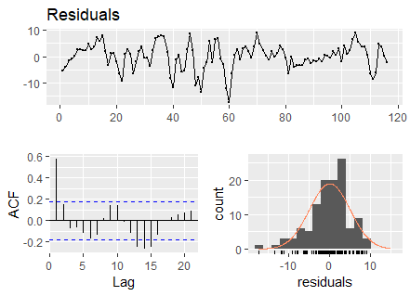

Breusch-Godfrey test for serial correlation of order up

to 10

data: Residuals

LM test = 50.263, df = 10, p-value = 2.388e-07

wcsres = resid(wcsts)

ggtsdisplay(wcsres)

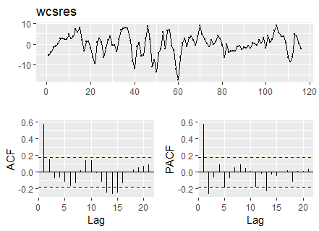

checkresiduals(wcsres)

##residuals

WCSBC = BoxCox(wcsrests,lambda=1/3)

ggtsdisplay(WCSBC)

WCSBC = BoxCox(wcsrests,lambda=1/3)+4

WCSBCTS = ts(WCSBC, start = c(2009,1), end = c(2018, 8), frequency = 12)

ggtsdisplay(WCSBCTS, main = "BoxCox'd WCS residuals")

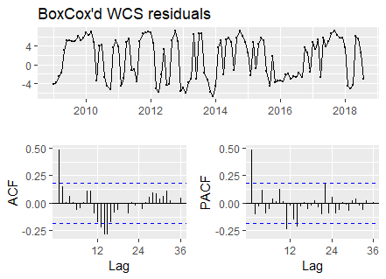

summary(ur.df(WCSBCTS, selectlags=c("Fixed")))

###############################################

# Augmented Dickey-Fuller Test Unit Root Test #

###############################################

Test regression none

Call:

lm(formula = z.diff ~ z.lag.1 - 1 + z.diff.lag)

Residuals:

Min 1Q Median 3Q Max

-8.023 -2.023 1.169 3.515 8.792

Coefficients:

Estimate Std. Error t value Pr(>|t|)

z.lag.1 -0.50603 0.09095 -5.564 1.82e-07 ***

z.diff.lag 0.07628 0.09444 0.808 0.421

---

Signif. codes: 0 ‘***’ 0.001 ‘**’ 0.01 ‘*’ 0.05 ‘.’ 0.1 ‘ ’ 1

Residual standard error: 3.992 on 112 degrees of freedom

Multiple R-squared: 0.2403, Adjusted R-squared: 0.2268

F-statistic: 17.72 on 2 and 112 DF, p-value: 2.064e-07

Value of test-statistic is: -5.5637

Critical values for test statistics:

1pct 5pct 10pct

tau1 -2.58 -1.95 -1.62

WCSAA = auto.arima(WCSBCTS)

Series: WCSBCTS

ARIMA(1,0,0) with non-zero mean

Coefficients:

ar1 mean

0.4898 1.2501

s.e. 0.0813 0.7050

sigma^2 estimated as 15.5: log likelihood=-322.71

AIC=651.42 AICc=651.63 BIC=659.68

Training set error measures:

ME RMSE MAE MPE MAPE

Training set 0.02943621 3.903467 3.37826 91.30734 92.27209

MASE ACF1

Training set 0.5937316 0.05003217

WCSA1 = Arima(WCSBCTS, order=c(1,0,1))

Series: WCSBCTS

ARIMA(1,0,1) with non-zero mean

Coefficients:

ar1 ma1 mean

0.3667 0.1657 1.2645

s.e. 0.1522 0.1530 0.6603

sigma^2 estimated as 15.5: log likelihood=-322.18

AIC=652.37 AICc=652.73 BIC=663.38

Training set error measures:

ME RMSE MAE MPE MAPE

Training set 0.02356449 3.885542 3.350293 90.77316 91.67773

MASE ACF1

Training set 0.5888164 0.004489298

#comparing forecasts of the 2 ARIMA models

WCSAAFC = forecast(WCSAA, h=24)

autoplot(WCSAAFC)

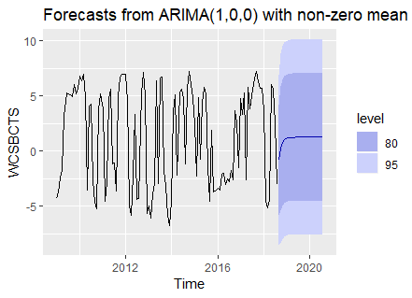

WCSA1FC = forecast(WCSA1, h=24)

autoplot(WCSA1FC)

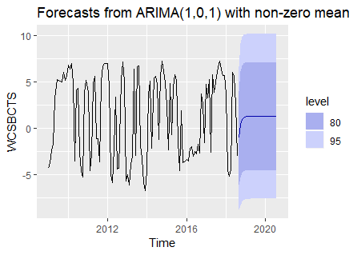

y = Arima(datats[,2],order=c(1,0,0),xreg=datats[,3:8])

y2 = Arima(datats[,2],order=c(1,0,1),xreg=datats[,3:8])

autoplot(forecast(y,xreg=datats[,3:8],h=10))+ylab("WCS prices")

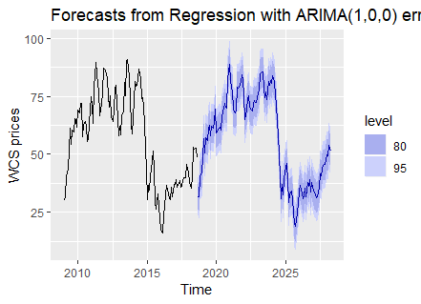

autoplot(forecast(y2,xreg=datats[,3:8]), h=10)+ylab("WCS prices")

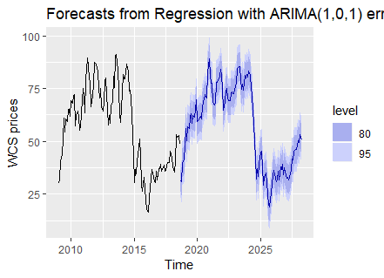

checkresiduals(y)

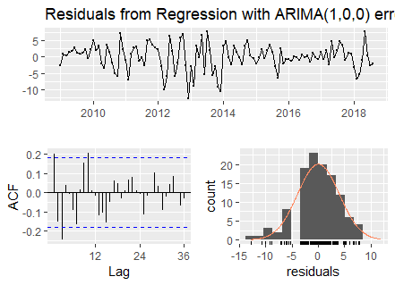

Ljung-Box test

data: Residuals from Regression with ARIMA(1,0,0) errors

Q* = 37.998, df = 15.2, p-value = 0.001004

Model df: 8. Total lags used: 23.2

checkresiduals(y2)

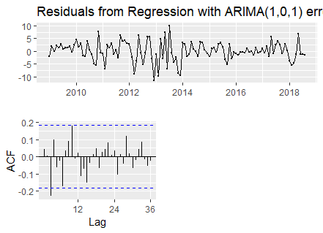

Ljung-Box test

data: Residuals from Regression with ARIMA(1,0,1) errors

Q* = 25.328, df = 14.2, p-value = 0.034

Model df: 9. Total lags used: 23.2

y3=auto.arima(datatsd[,2],xreg=datatsd[,3:8])+ylab("WCS prices")

summary(y3)

Series: datatsd[, 2]

Regression with ARIMA(0,0,0) errors

Coefficients:

WTI MAYA EXCH PADD2 PADD3 Usimports

0.8934 0.1104 31.4817 -0.0428 0.1505 -1e-04

s.e. 0.1974 0.2074 21.6186 0.1093 0.1093 1e-04

sigma^2 estimated as 20.05: log likelihood=-332.5

AIC=679 AICc=680.05 BIC=698.21

Training set error measures:

ME RMSE MAE MPE MAPE

Training set -0.04150332 4.359538 3.158901 233.0862 328.209

MASE ACF1

Training set 0.433464 0.09499232

summary(y2)

Series: datats[, 2]

Regression with ARIMA(1,0,1) errors

Coefficients:

ar1 ma1 intercept WTI MAYA EXCH

0.4502 0.3738 -15.8270 0.8825 -0.0069 12.9697

s.e. 0.1074 0.0951 21.1481 0.1425 0.1366 15.5341

PADD2 PADD3 Usimports

-0.0682 0.1282 -1e-04

s.e. 0.1078 0.1132 1e-04

sigma^2 estimated as 15.38: log likelihood=-318.78

AIC=657.55 AICc=659.65 BIC=685.09

Training set error measures:

ME RMSE MAE MPE MAPE

Training set 0.01859494 3.766594 2.857398 -0.4390813 5.210017

MASE ACF1

Training set 0.1949726 0.04361119

auto.arima(diff(datats[,2]))

Series: diff(datats[, 2])

ARIMA(0,0,0) with zero mean

sigma^2 estimated as 44.92: log likelihood=-381.96

AIC=765.93 AICc=765.96 BIC=768.67

auto.arima(datats[,2])

Series: datats[, 2]

ARIMA(0,1,0)

sigma^2 estimated as 44.92: log likelihood=-381.96

AIC=765.93 AICc=765.96 BIC=768.67

checkresiduals(diff(datats[,2]))

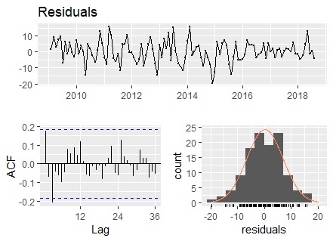

ynaive = naive(datats[,2],12)

autoplot(ynaive)+ylab("WCS Prices")

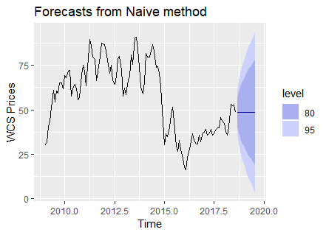

ynaive1 = naive(datats[,2],1)

summary(ynaive1)

Forecast method: Naive method

Model Information:

Call: naive(y = datats[, 2], h = 1)

Residual sd: 6.7025

Error measures:

ME RMSE MAE MPE MAPE

Training set 0.1615652 6.702486 5.293739 -0.4443802 10.24452

MASE ACF1

Training set 0.3612146 0.1735094

Forecasts:

Point Forecast Lo 80 Hi 80 Lo 95 Hi 95

Sep 2018 48.55 39.96042 57.13958 35.41337 61.68663

library(vars)

X493tpdatavar <- read_excel("C:/Users/Tim/Desktop/493tpdatavar.xlsx"[3])

data2 = data.frame(X493tpdatavar)

datats2 = ts(data2,start=c(2009,1),end=c(2018,8),frequency=12)

VARselect(datats2[,2:5], lag.max=8,

type="const")[["selection"]]

AIC(n) HQ(n) SC(n) FPE(n)

2 1 1 2

var1 <- VAR(datats2[,2:5], p=1, type="const")

serial.test(var1, lags.pt=10, type="PT.asymptotic")

Portmanteau Test (asymptotic)

data: Residuals of VAR object var1

Chi-squared = 185.51, df = 144, p-value = 0.01123

var2 <- VAR(datats2[,2:5], p=2, type="const")

serial.test(var2, lags.pt=10, type="PT.asymptotic")

Portmanteau Test (asymptotic)

data: Residuals of VAR object var2

Chi-squared = 132.21, df = 128, p-value = 0.3814

varfc = forecast(var2,h=12)

varfc

WCS

Point Forecast Lo 80 Hi 80 Lo 95 Hi 95

Sep 2018 45.35022 37.57772 53.12272 33.46321 57.23723

Oct 2018 43.28477 32.05828 54.51126 26.11534 60.45420

Nov 2018 42.13080 29.10844 55.15316 22.21482 62.04679

Dec 2018 41.45449 27.26013 55.64884 19.74610 63.16287

Jan 2019 40.89529 25.82441 55.96617 17.84637 63.94421

Feb 2019 40.30836 24.52415 56.09256 16.16850 64.44822

Mar 2019 39.71667 23.28182 56.15153 14.58173 64.85161

Apr 2019 39.19746 22.13356 56.26135 13.10048 65.29443

May 2019 38.80327 21.13403 56.47251 11.78049 65.82604

Jun 2019 38.54133 20.29927 56.78339 10.64250 66.44016

WTI

Point Forecast Lo 80 Hi 80 Lo 95 Hi 95

Sep 2018 65.34426 58.88406 71.80447 55.46424 75.22429

Oct 2018 63.06423 53.16720 72.96126 47.92802 78.20043

Nov 2018 61.19359 48.99080 73.39638 42.53103 79.85614

Dec 2018 59.61332 45.77104 73.45559 38.44339 80.78324

Jan 2019 58.24733 43.14633 73.34832 35.15235 81.34230

Feb 2019 57.07806 40.93545 73.22067 32.39007 81.76605

Mar 2019 56.10856 39.05981 73.15731 30.03475 82.18237

Apr 2019 55.33302 37.47400 73.19205 28.02000 82.64604

May 2019 54.73091 36.13455 73.32728 26.29023 83.17160

Jun 2019 54.27446 34.99734 73.55158 24.79264 83.75628

EXCH

Point Forecast Lo 80 Hi 80 Lo 95 Hi 95

Sep 2018 1.302443 1.275090 1.329797 1.260610 1.344277

Oct 2018 1.304512 1.259493 1.349532 1.235661 1.373364

Nov 2018 1.307770 1.248538 1.367003 1.217183 1.398358

Dec 2018 1.310814 1.239453 1.382174 1.201678 1.419950

Jan 2019 1.313050 1.231089 1.395011 1.187702 1.438398

Feb 2019 1.314349 1.223079 1.405618 1.174763 1.453934

Mar 2019 1.314829 1.215323 1.414334 1.162648 1.467009

Apr 2019 1.314700 1.207813 1.421587 1.151230 1.478170

May 2019 1.314151 1.200557 1.427745 1.140424 1.487878

Jun 2019 1.313300 1.193546 1.433055 1.130151 1.496449

PADD2

Point Forecast Lo 80 Hi 80 Lo 95 Hi 95

Sep 2018 96.88799 92.55513 101.22086 90.26145 103.5145

Oct 2018 95.68876 90.72670 100.65083 88.09994 103.2776

Nov 2018 94.85032 89.72187 99.97877 87.00703 102.6936

Dec 2018 94.42027 89.15140 99.68915 86.36223 102.4783

Jan 2019 94.22255 88.85133 99.59377 86.00798 102.4371

Feb 2019 94.10667 88.65672 99.55662 85.77169 102.4417

Mar 2019 93.99264 88.47947 99.50581 85.56098 102.4243

Apr 2019 93.85741 88.29699 99.41784 85.35348 102.3613

May 2019 93.70950 88.11376 99.30523 85.15156 102.2674

Jun 2019 93.56597 87.94201 99.18993 84.96486 102.1671

> varfc

WCS

Point Forecast Lo 80 Hi 80 Lo 95 Hi 95

Sep 2018 45.35022 37.57772 53.12272 33.46321 57.23723

Oct 2018 43.28477 32.05828 54.51126 26.11534 60.45420

Nov 2018 42.13080 29.10844 55.15316 22.21482 62.04679

Dec 2018 41.45449 27.26013 55.64884 19.74610 63.16287

Jan 2019 40.89529 25.82441 55.96617 17.84637 63.94421

Feb 2019 40.30836 24.52415 56.09256 16.16850 64.44822

Mar 2019 39.71667 23.28182 56.15153 14.58173 64.85161

Apr 2019 39.19746 22.13356 56.26135 13.10048 65.29443

May 2019 38.80327 21.13403 56.47251 11.78049 65.82604

Jun 2019 38.54133 20.29927 56.78339 10.64250 66.44016

WTI

Point Forecast Lo 80 Hi 80 Lo 95 Hi 95

Sep 2018 65.34426 58.88406 71.80447 55.46424 75.22429

Oct 2018 63.06423 53.16720 72.96126 47.92802 78.20043

Nov 2018 61.19359 48.99080 73.39638 42.53103 79.85614

Dec 2018 59.61332 45.77104 73.45559 38.44339 80.78324

Jan 2019 58.24733 43.14633 73.34832 35.15235 81.34230

Feb 2019 57.07806 40.93545 73.22067 32.39007 81.76605

Mar 2019 56.10856 39.05981 73.15731 30.03475 82.18237

Apr 2019 55.33302 37.47400 73.19205 28.02000 82.64604

May 2019 54.73091 36.13455 73.32728 26.29023 83.17160

Jun 2019 54.27446 34.99734 73.55158 24.79264 83.75628

EXCH

Point Forecast Lo 80 Hi 80 Lo 95 Hi 95

Sep 2018 1.302443 1.275090 1.329797 1.260610 1.344277

Oct 2018 1.304512 1.259493 1.349532 1.235661 1.373364

Nov 2018 1.307770 1.248538 1.367003 1.217183 1.398358

Dec 2018 1.310814 1.239453 1.382174 1.201678 1.419950

Jan 2019 1.313050 1.231089 1.395011 1.187702 1.438398

Feb 2019 1.314349 1.223079 1.405618 1.174763 1.453934

Mar 2019 1.314829 1.215323 1.414334 1.162648 1.467009

Apr 2019 1.314700 1.207813 1.421587 1.151230 1.478170

May 2019 1.314151 1.200557 1.427745 1.140424 1.487878

Jun 2019 1.313300 1.193546 1.433055 1.130151 1.496449

PADD2

Point Forecast Lo 80 Hi 80 Lo 95 Hi 95

Sep 2018 96.88799 92.55513 101.22086 90.26145 103.5145

Oct 2018 95.68876 90.72670 100.65083 88.09994 103.2776

Nov 2018 94.85032 89.72187 99.97877 87.00703 102.6936

Dec 2018 94.42027 89.15140 99.68915 86.36223 102.4783

Jan 2019 94.22255 88.85133 99.59377 86.00798 102.4371

Feb 2019 94.10667 88.65672 99.55662 85.77169 102.4417

Mar 2019 93.99264 88.47947 99.50581 85.56098 102.4243

Apr 2019 93.85741 88.29699 99.41784 85.35348 102.3613

May 2019 93.70950 88.11376 99.30523 85.15156 102.2674

Jun 2019 93.56597 87.94201 99.18993 84.96486 102.1671

summary(varfc)

Forecast method: VAR(2)

Model Information:

VAR Estimation Results:

=======================

Estimated coefficients for equation WCS:

========================================

Call:

WCS = WCS.l1 + WTI.l1 + EXCH.l1 + PADD2.l1 + WCS.l2 + WTI.l2 + EXCH.l2 + PADD2.l2 + const

WCS.l1 WTI.l1 EXCH.l1 PADD2.l1

0.75631071 0.34521136 -26.29939324 -0.03058105

WCS.l2 WTI.l2 EXCH.l2 PADD2.l2

-0.29726998 -0.07366527 -0.12175725 -0.10052063

const

53.05041406

Estimated coefficients for equation WTI:

========================================

Call:

WTI = WCS.l1 + WTI.l1 + EXCH.l1 + PADD2.l1 + WCS.l2 + WTI.l2 + EXCH.l2 + PADD2.l2 + const

WCS.l1 WTI.l1 EXCH.l1 PADD2.l1

-0.174806343 1.267158771 -17.711489443 -0.091095704

WCS.l2 WTI.l2 EXCH.l2 PADD2.l2

0.119582214 -0.356238005 0.791105146 -0.002376088

const

37.724219641

Estimated coefficients for equation EXCH:

=========================================

Call:

EXCH = WCS.l1 + WTI.l1 + EXCH.l1 + PADD2.l1 + WCS.l2 + WTI.l2 + EXCH.l2 + PADD2.l2 + const

WCS.l1 WTI.l1 EXCH.l1 PADD2.l1

-0.0001474375 -0.0001995927 1.2600409085 0.0001102051

WCS.l2 WTI.l2 EXCH.l2 PADD2.l2

-0.0005853439 0.0008114515 -0.2840385542 0.0002367464

const

-0.0070170925

Estimated coefficients for equation PADD2:

==========================================

Call:

PADD2 = WCS.l1 + WTI.l1 + EXCH.l1 + PADD2.l1 + WCS.l2 + WTI.l2 + EXCH.l2 + PADD2.l2 + const

WCS.l1 WTI.l1 EXCH.l1 PADD2.l1 WCS.l2

0.03677079 0.03161204 24.28642200 0.52283153 0.04965382

WTI.l2 EXCH.l2 PADD2.l2 const

0.01769518 -1.64993196 -0.14765717 22.60113540

Error measures:

autoplot(varfc)

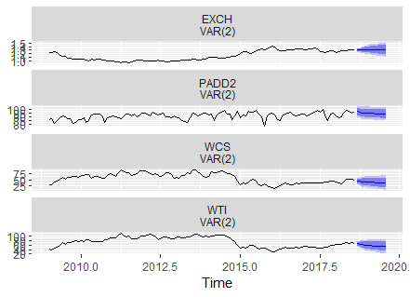

1. **References**

* **Data sources**
  + [“Economic Dashboard.” *Oil Prices*, 26 Oct. 2018, economicdashboard.alberta.ca/OilPrice.](https://economicdashboard.alberta.ca/OilPrice)
  + “US FOB Costs of Mexican MAYA Crude Oil.” *Factors Affecting Gasoline Prices - Energy Explained, Your Guide To Understanding Energy - Energy Information Administration*, 1 Nov. 2018, www.eia.gov/dnav/pet/hist/LeafHandler.ashx?n=PET&s=IMX2810004&f=M.
  + “Midwest (PADD II) Percent Utilization of Refinery Operable Capacity.” *Factors Affecting Gasoline Prices - Energy Explained, Your Guide To Understanding Energy - Energy Information Administration*, 31 Oct. 2018, www.eia.gov/dnav/pet/hist/LeafHandler.ashx?n=PET&s=MOPUEP22&f=M.
  + “Midwest (PADD III) Percent Utilization of Refinery Operable Capacity.” *Factors Affecting Gasoline Prices - Energy Explained, Your Guide To Understanding Energy - Energy Information Administration*, 31 Oct. 2018, www.eia.gov/dnav/pet/hist/LeafHandler.ashx?n=PET&s=MOPUEP32&f=M.
  + “Canada / U.S. Foreign Exchange Rate.” *FRED*, Federal Reserve Bank of St. Louis, 13 Nov. 2018, fred.stlouisfed.org/series/EXCAUS.
  + “US Imports from Canada of Crude Oil.” *Factors Affecting Gasoline Prices - Energy Explained, Your Guide To Understanding Energy - Energy Information Administration*, 31 Oct. 2018, www.eia.gov/dnav/pet/hist/LeafHandler.ashx?n=PET&s=MCRIMUSCA1&f=M.
* **Other**
  + BUEC 463, ECON 366 class notes for Economic modeling
  + ECON 493 class notes, provided source materials for statistical modeling

1. Information taken from BUEC 463 professor, who is the head of the Department of Energy in the GoA
2. Most of the oil goes to PADD II anyways, and oil that goes to PADD II are priced against WTI, not MAYA; US imports, when regressed to WCS prices, seem to have an insignificant effect.
3. NOTE: This is NOT a different data set; it’s just a separate spreadsheet containing less of the variables from the main spreadsheet for easy access.